I just want to discuss how to stop the debugger. Now, it may seem fairly simple, but there are two ways you can stop debugging your program.

The first way is by pressing the F8 key, and letting your program run all the way through to the end. But, keep in mind, if you have any grey points or watch points set, the program execution will most likely pause, and you'll have to press F8 key again, and maybe keep doing it in a cycle until the program finishes. And, you need to bear in mind that you are counting on your program executing successfully.

If your program causes any runtime errors, your debug session will terminate, and you'll be returned to the SAP menu screen, which can be just damn annoying. Because you just want to get back to a SE38.

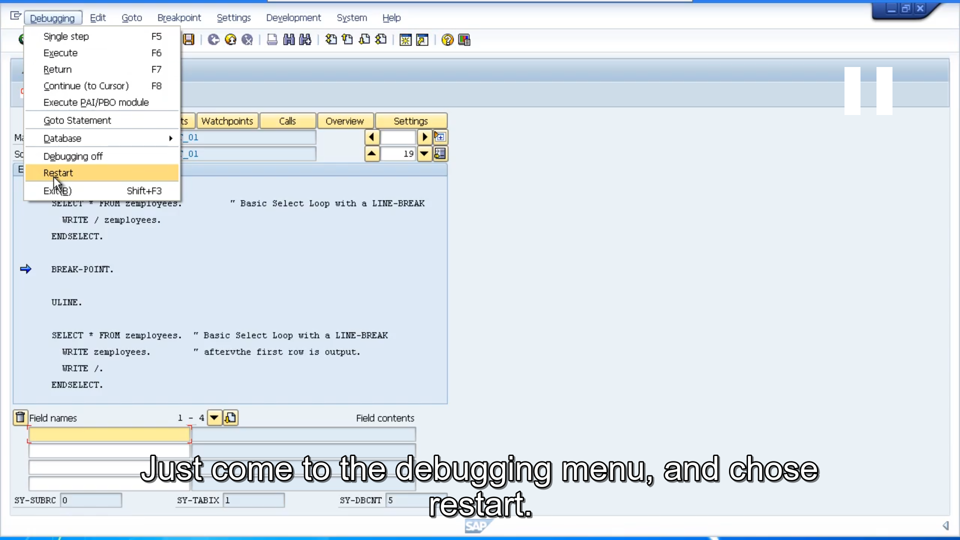

The alternate way of stopping the debugger. Just come to the debugging menu, and chose restart. That way, no more program code will be executed, and you'll be returned to the SE38 front screen.